**Machine ID: VBDOTNET-Stu-87-VBDOTNET-CTS**

**Hosted URL:**

* **UI -** [**http://localhost/**](http://localhost/)
* **API -** [**http://fsetaskmgr.net/**](http://fsetaskmgr.net/)

**SCM:**

* **UI -** [**https://github.com/venkatdev22/Cap_Task_UI**](https://github.com/venkatdev22/Cap_Task_UI)
* **API - https://github.com/venkatdev22/FSE_Cap_TaskMGRAPI**

**Dev File path:**

* **UI - C:\Users\Administrator\Source\capangular\taskmanager**
* **API - C:\Users\Administrator\Source\Repos\FSE_Cap_TaskMGRAPI**

Project Manager

Screen 1 – Add project

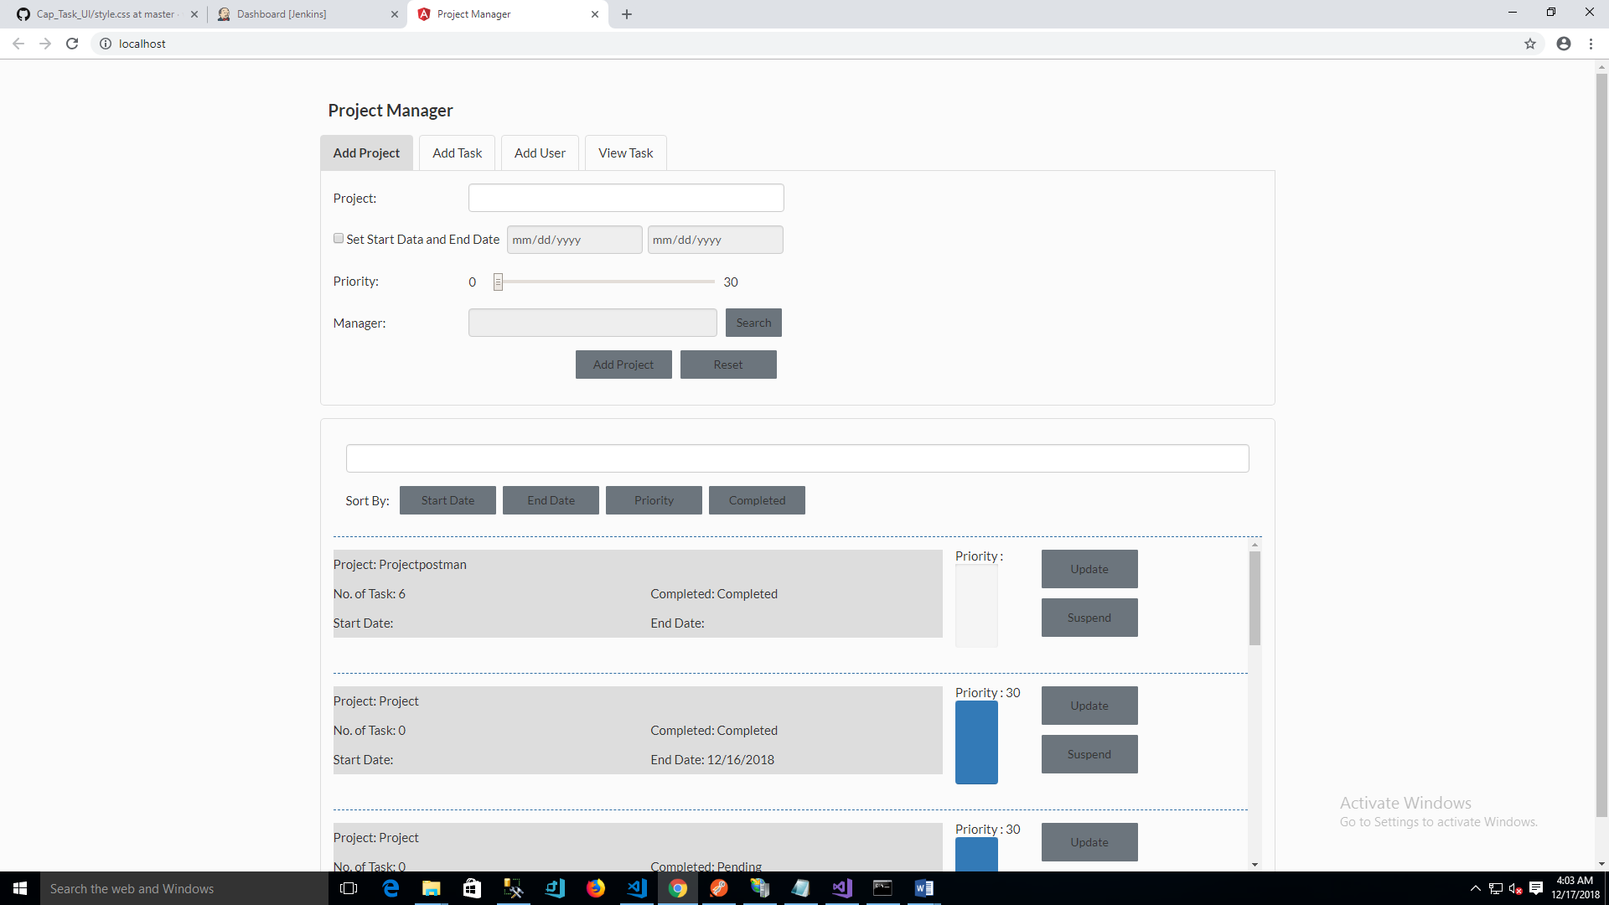

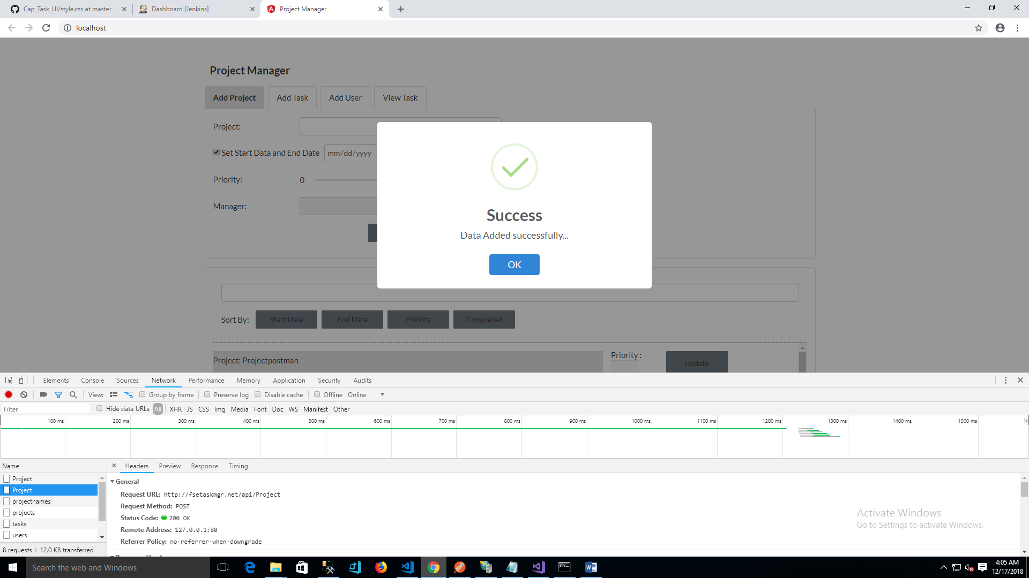

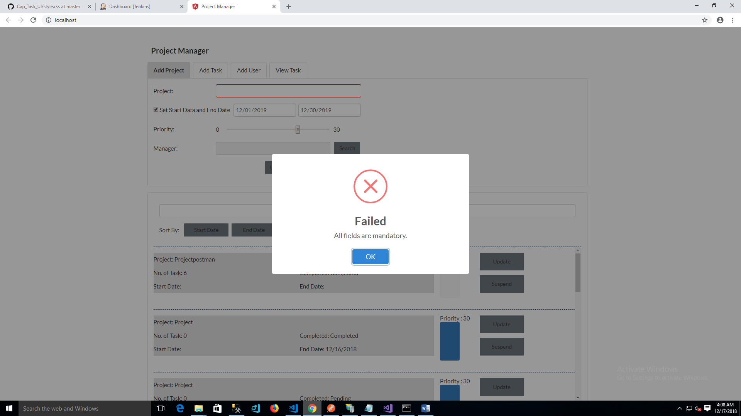

Update project

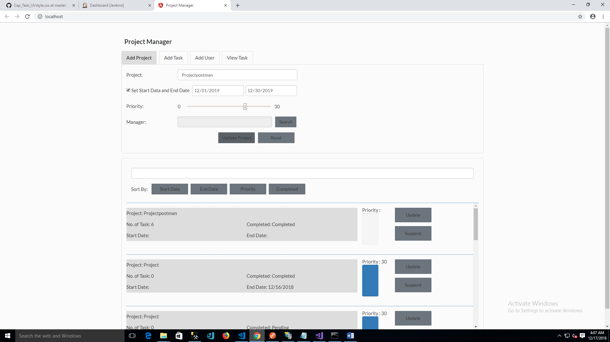

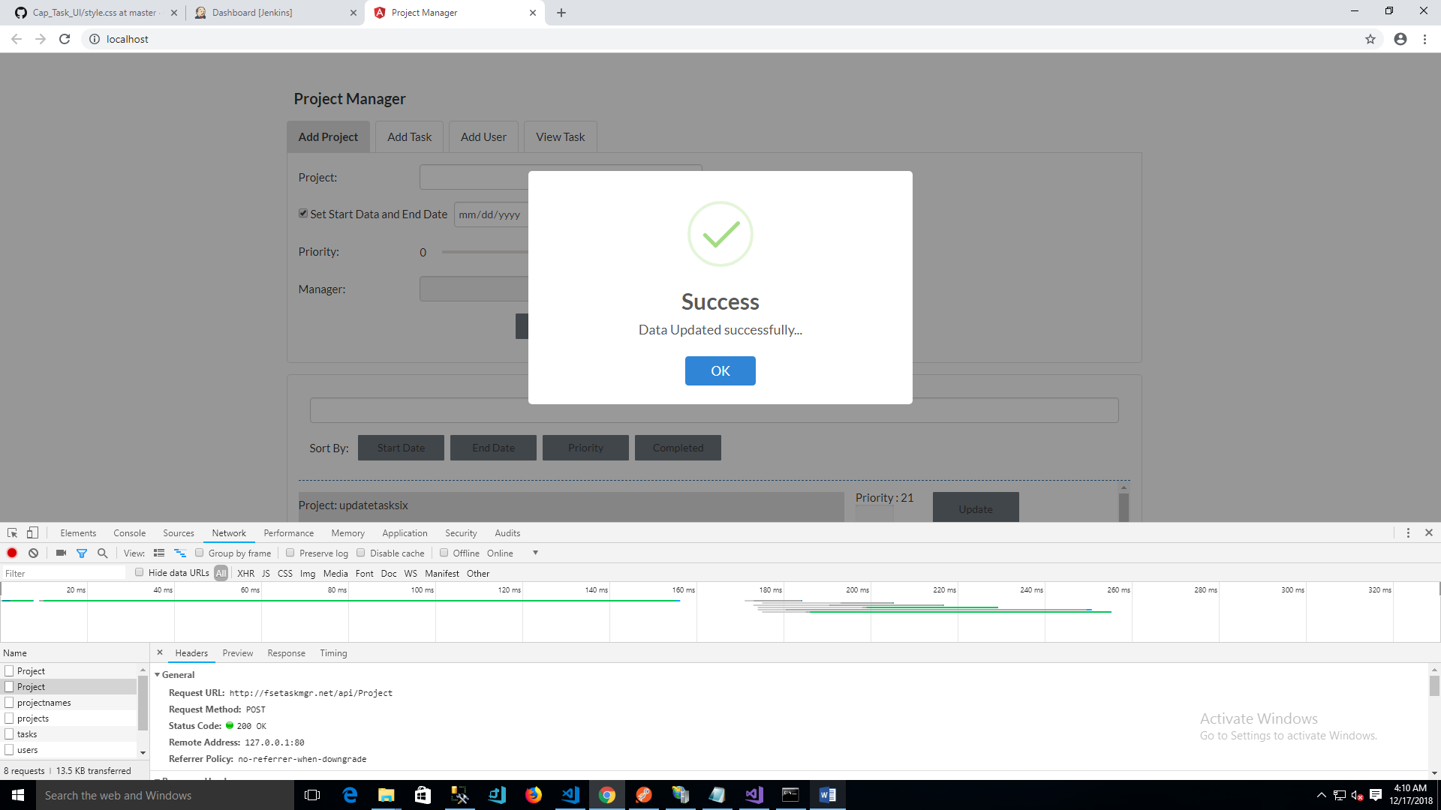

Screen2 – Add Task

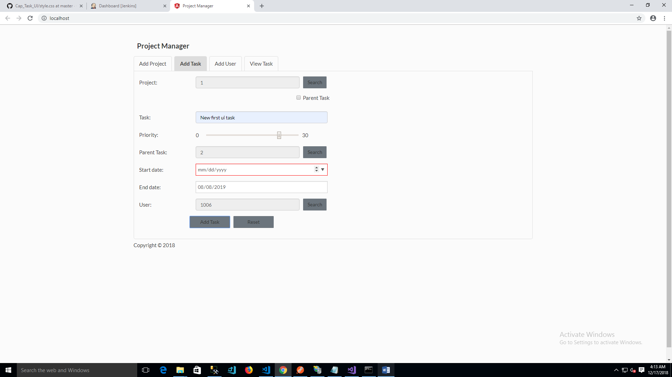

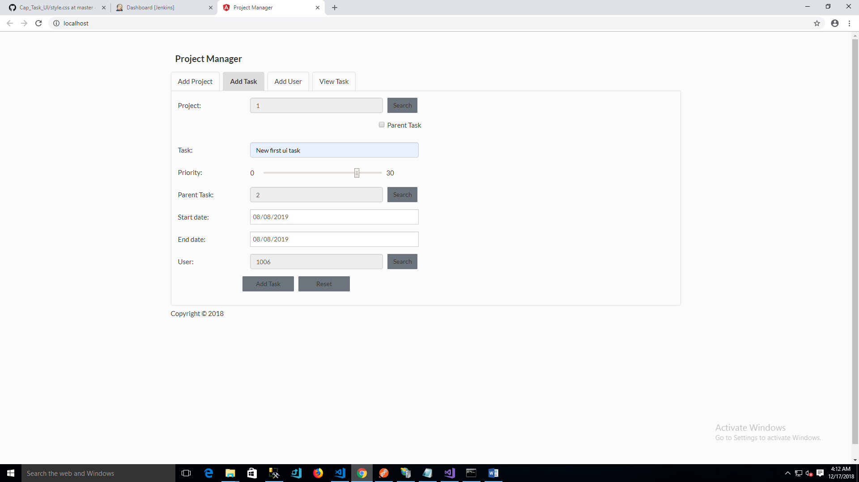

Add Task – Search User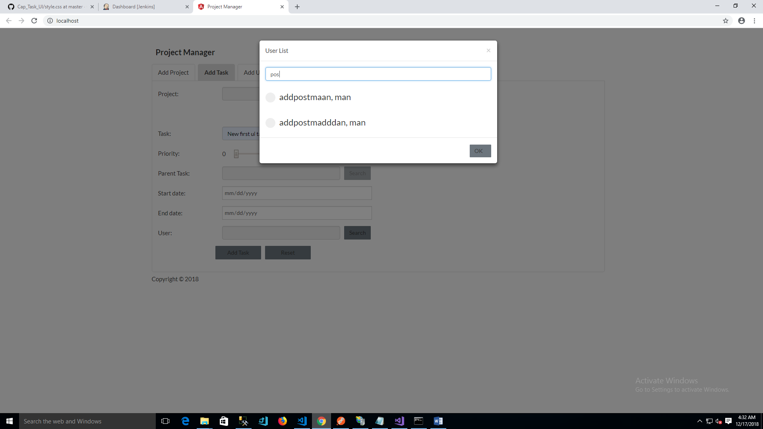

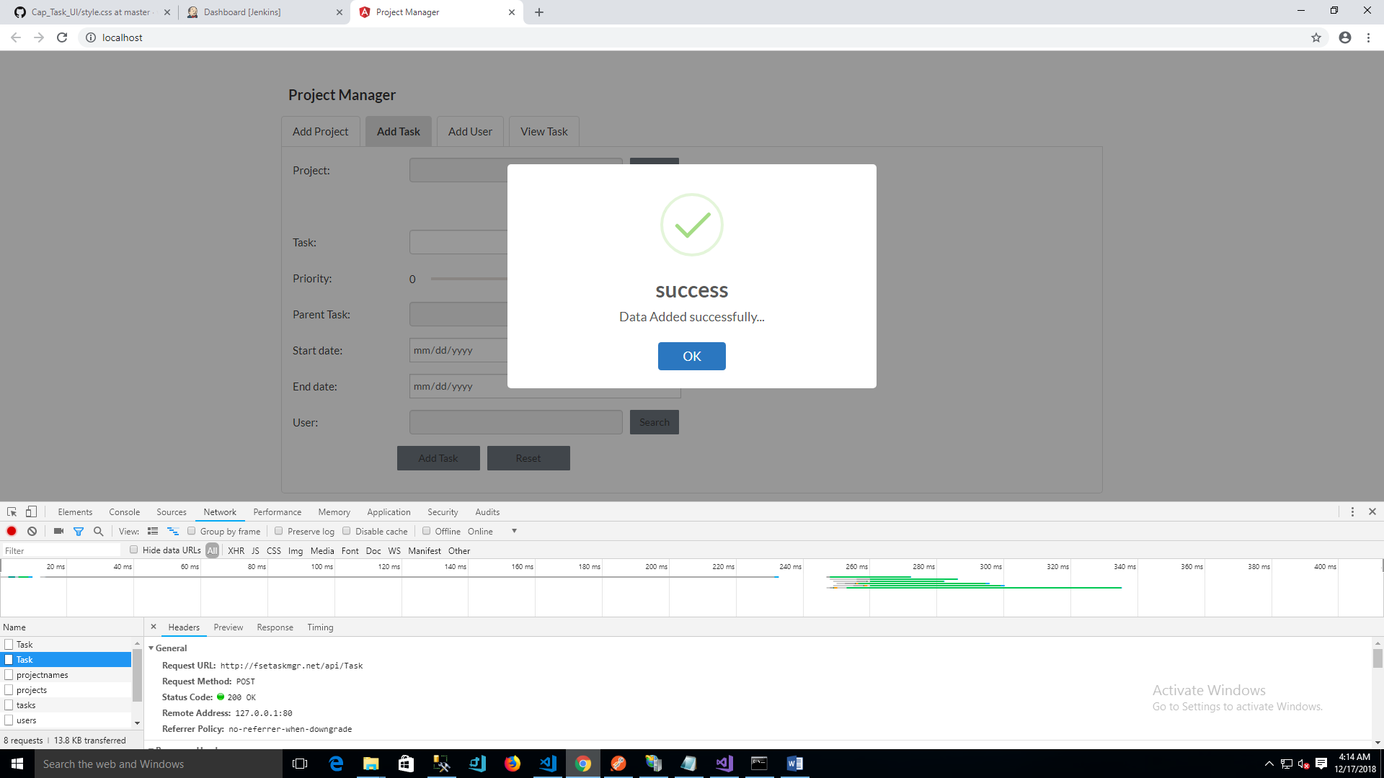

Screen3 – Add user

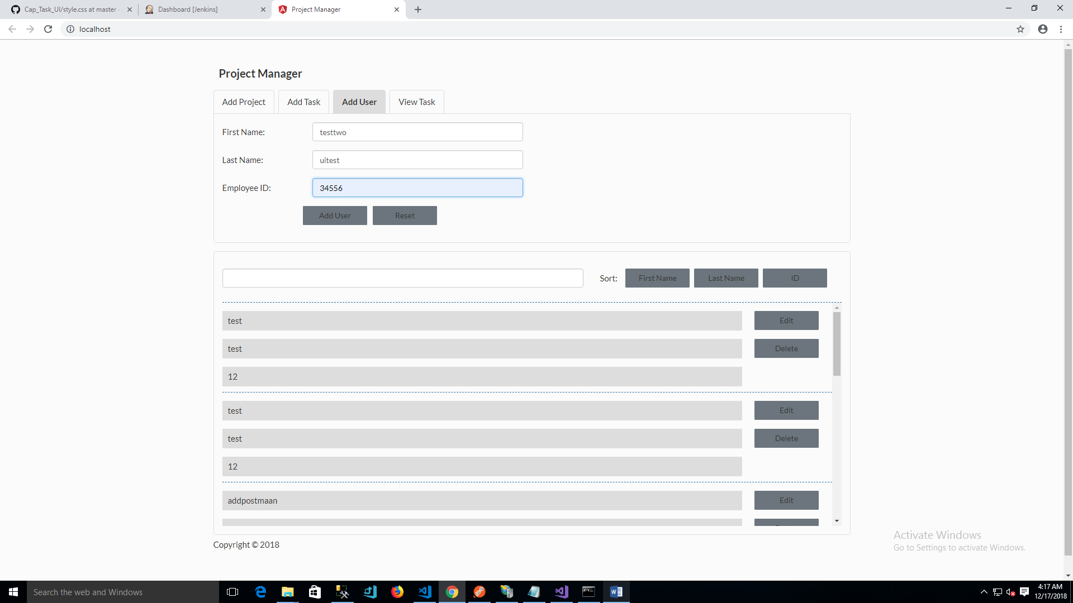

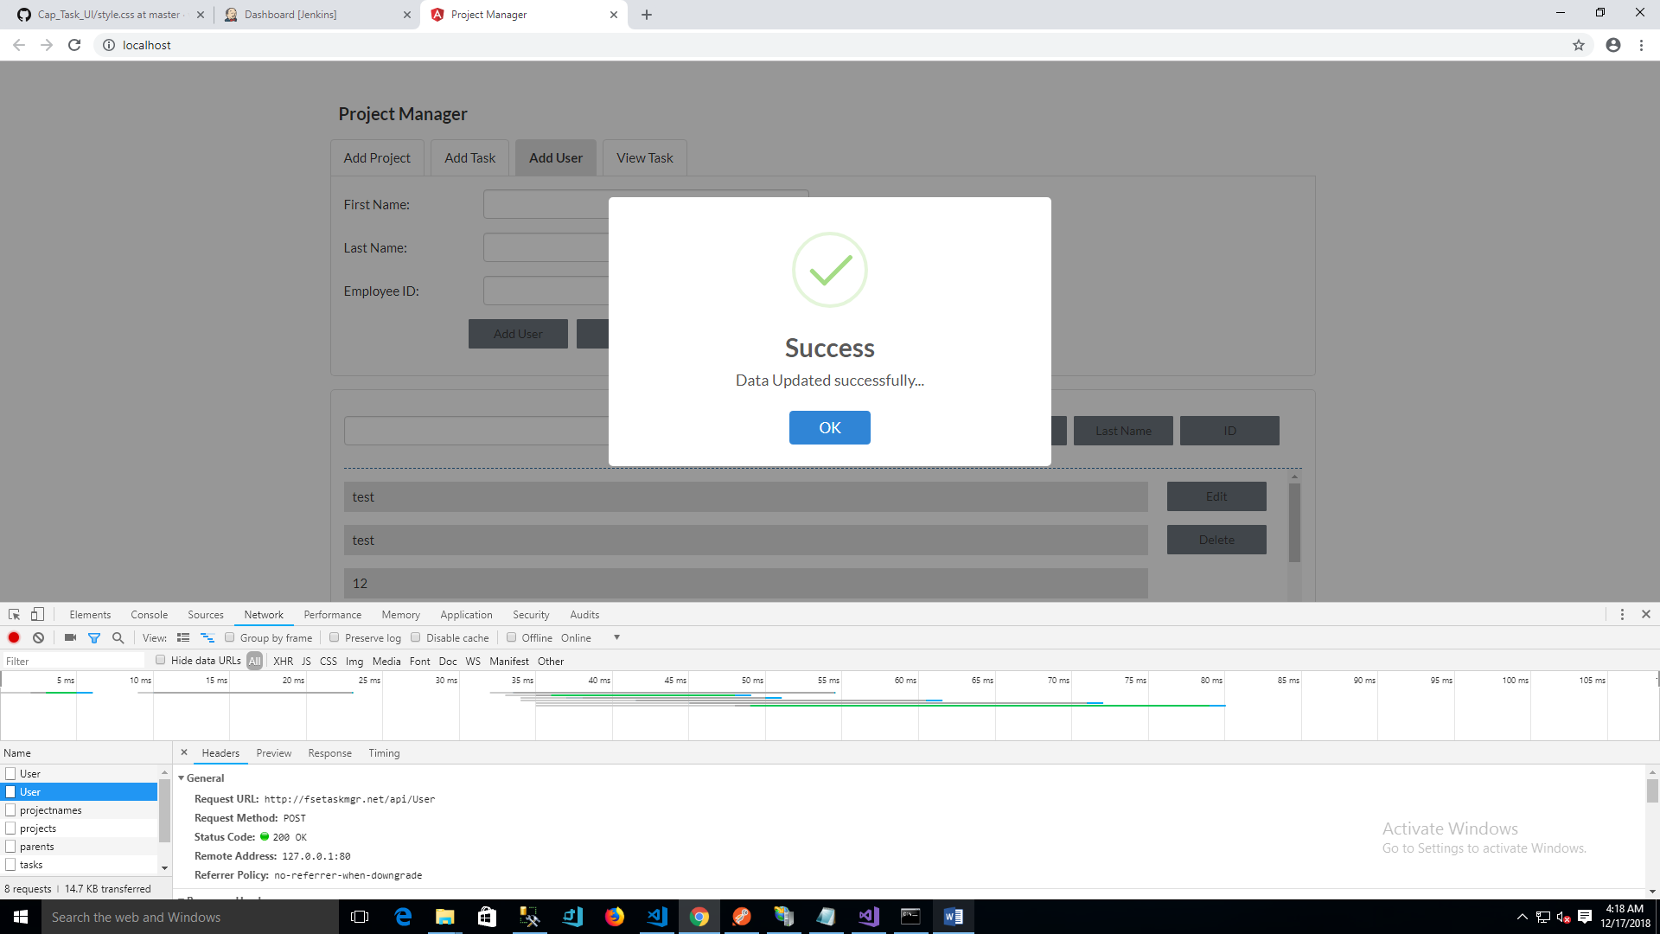

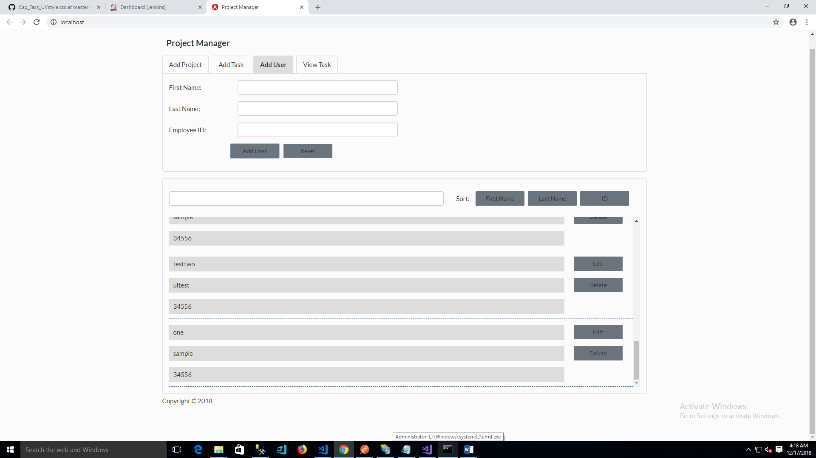

Screen 4 – View Task

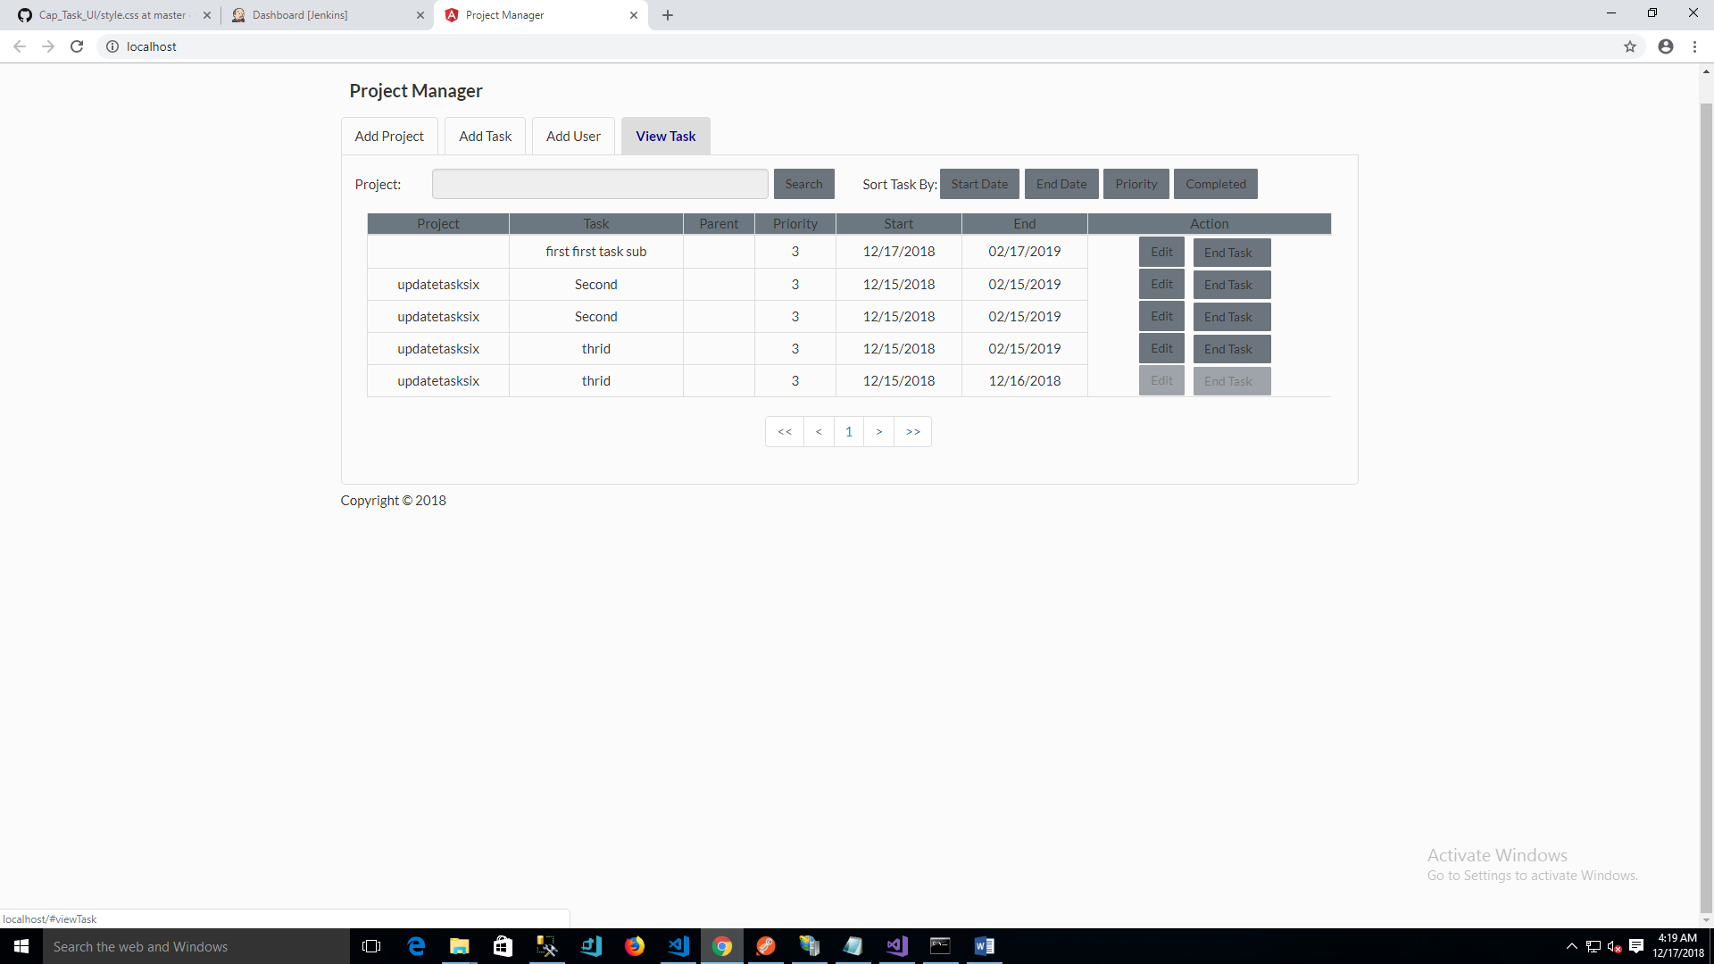

Proejct Search

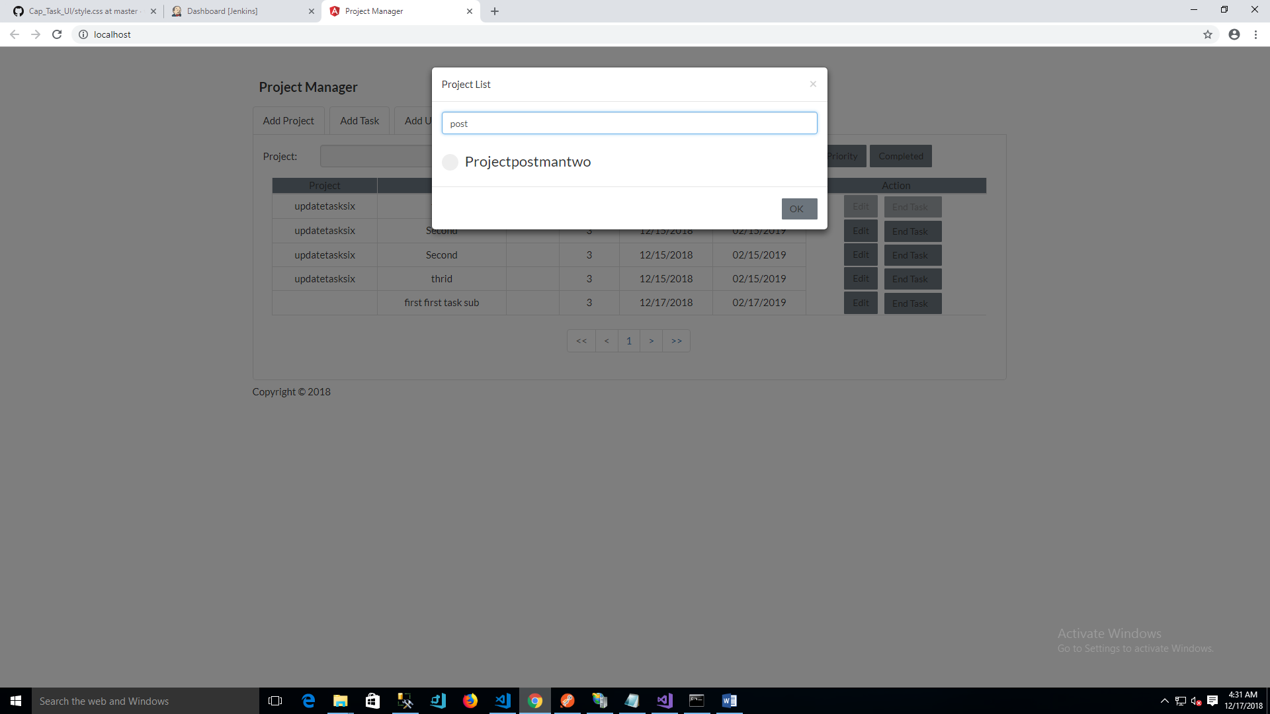

View Task - Sorting

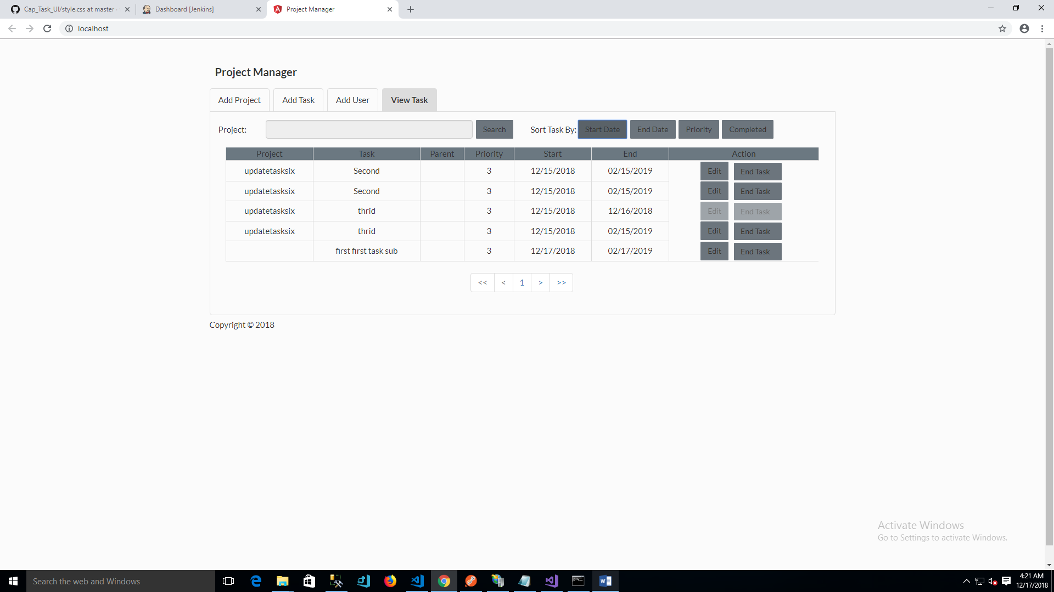

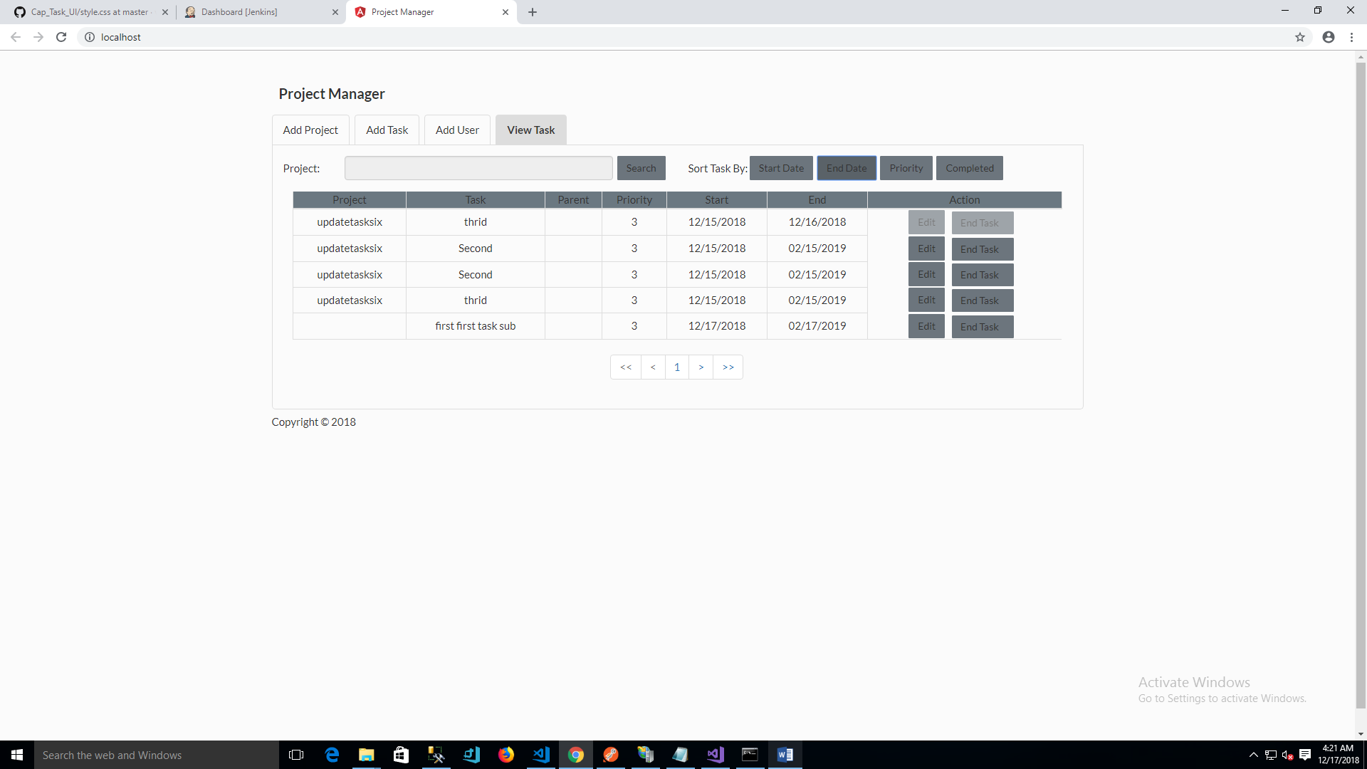

Unit Test

Nunit

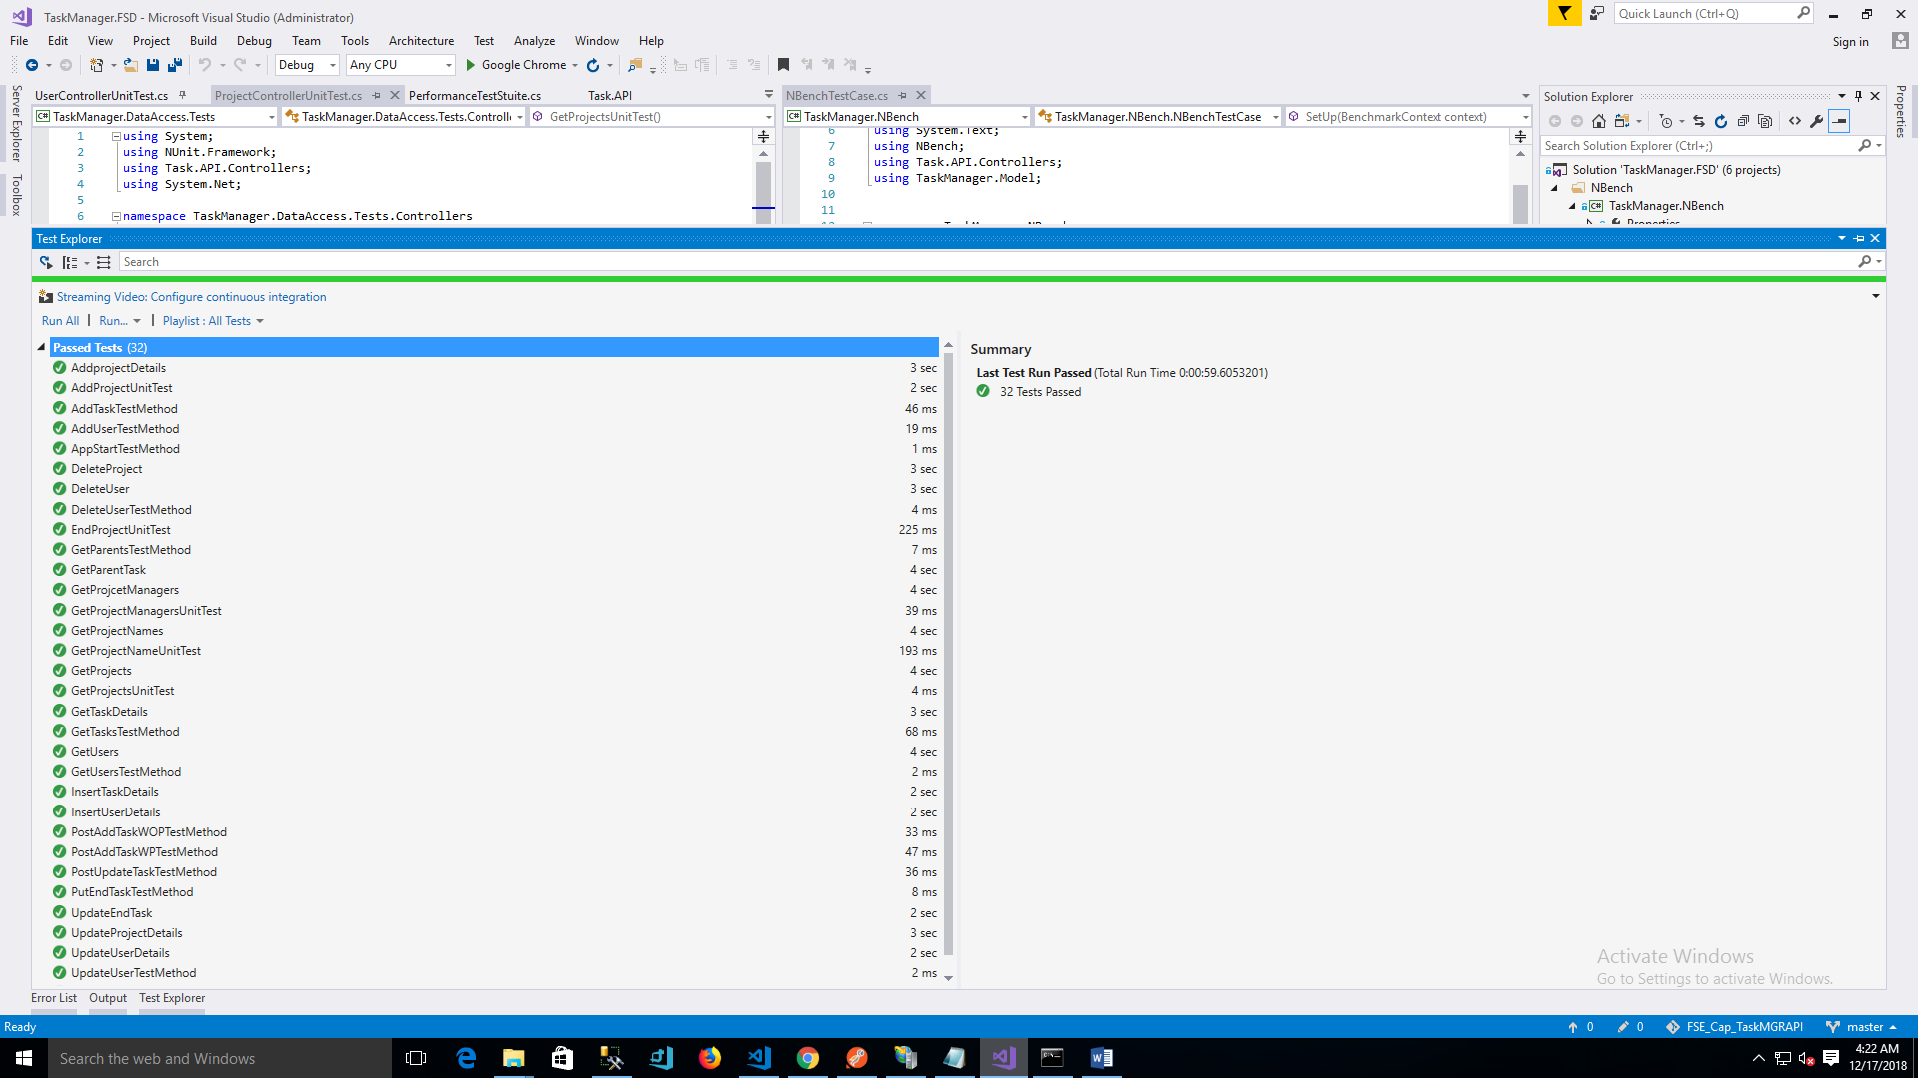

NBench runner

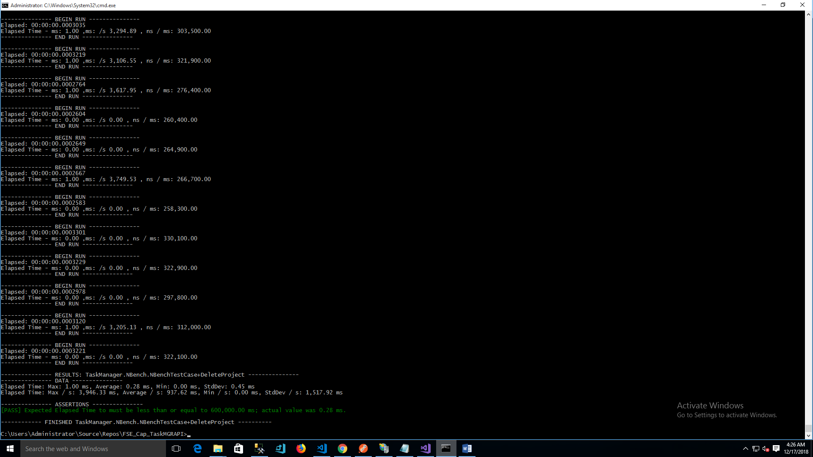

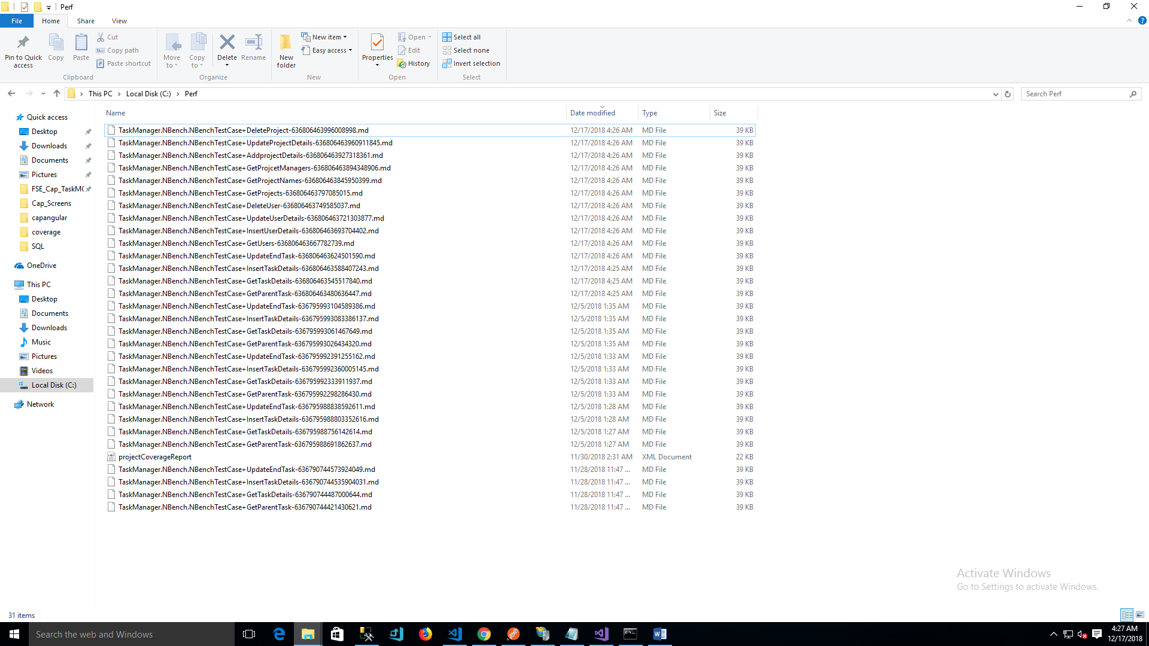

Coverage runner

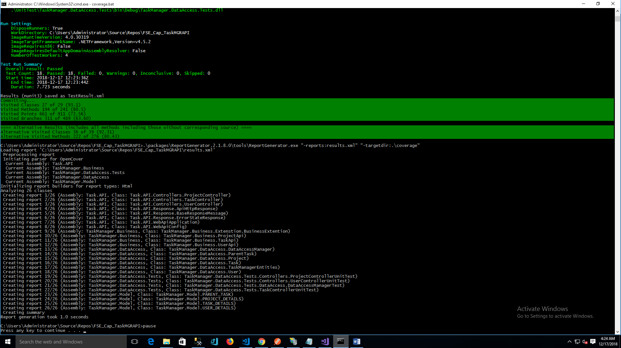

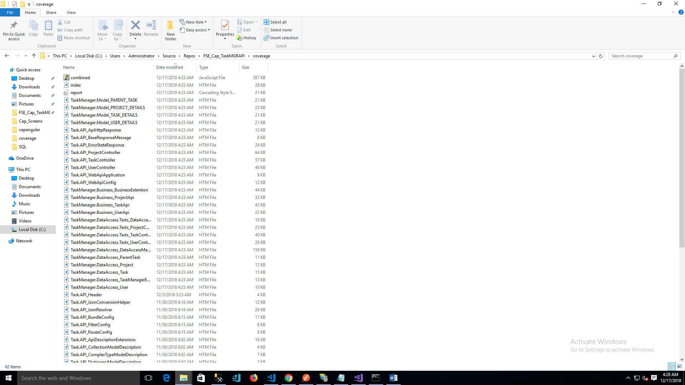

.Net Jenkins CI

URL:

<http://localhost:8080/>

User: Admin

Password: 0289cb636b874d33a5c1ea0db1668eed

Success Full Build output:

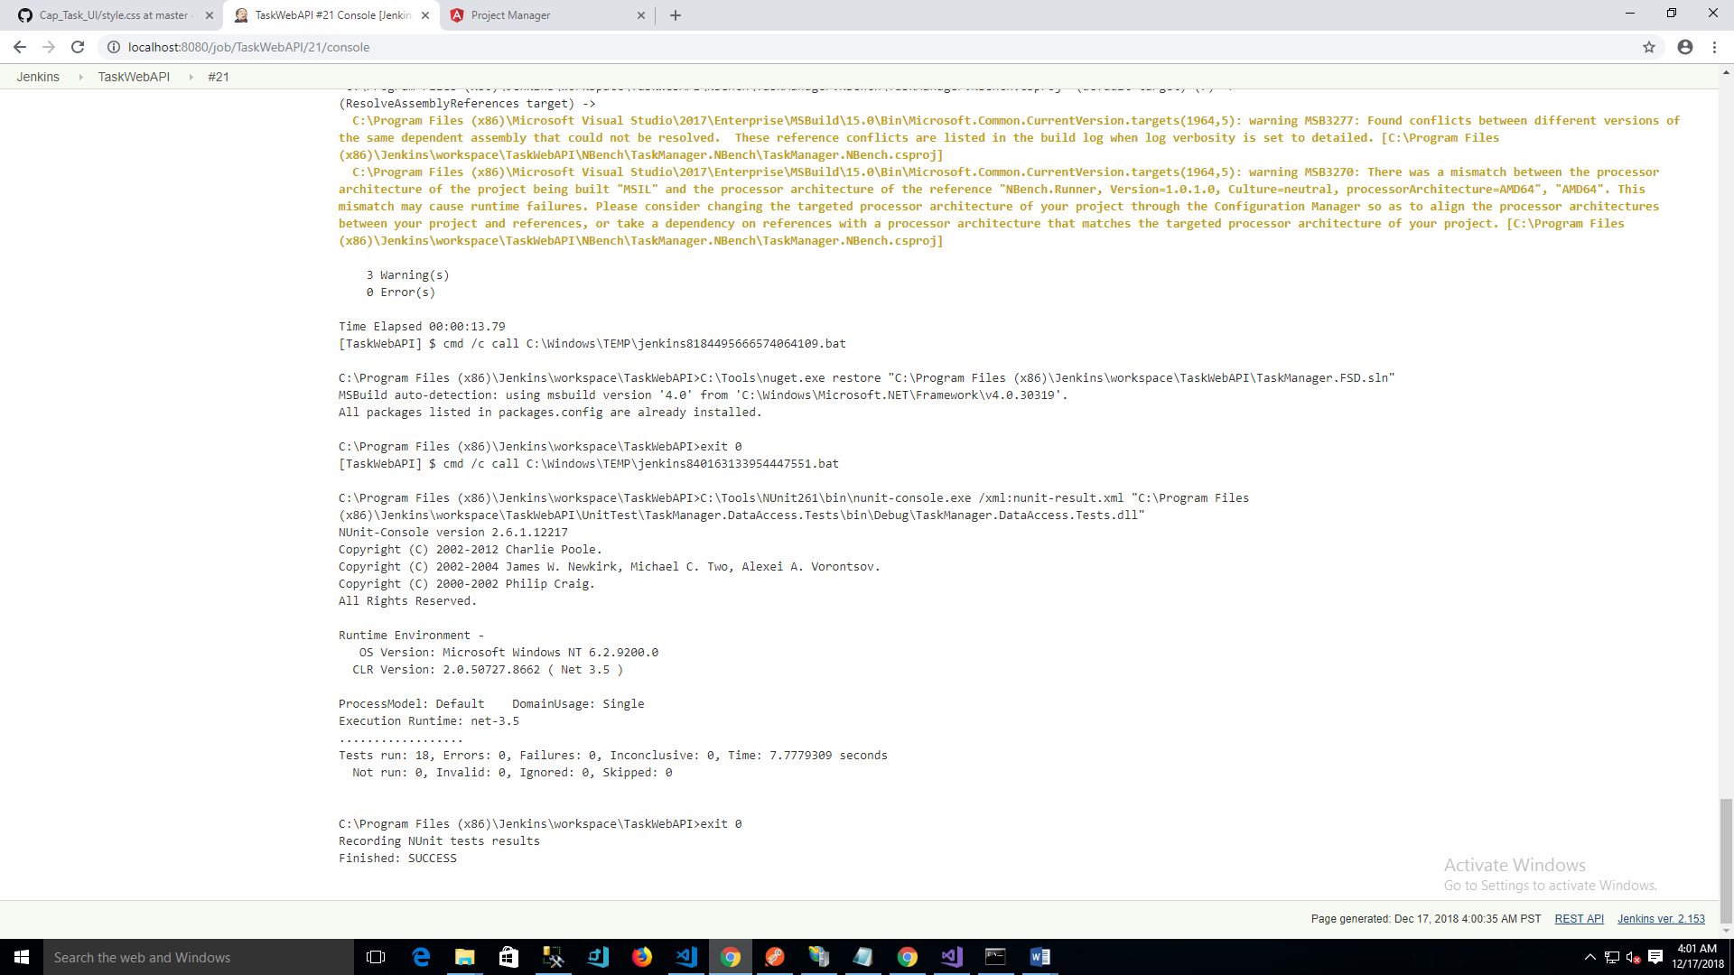

Test Results

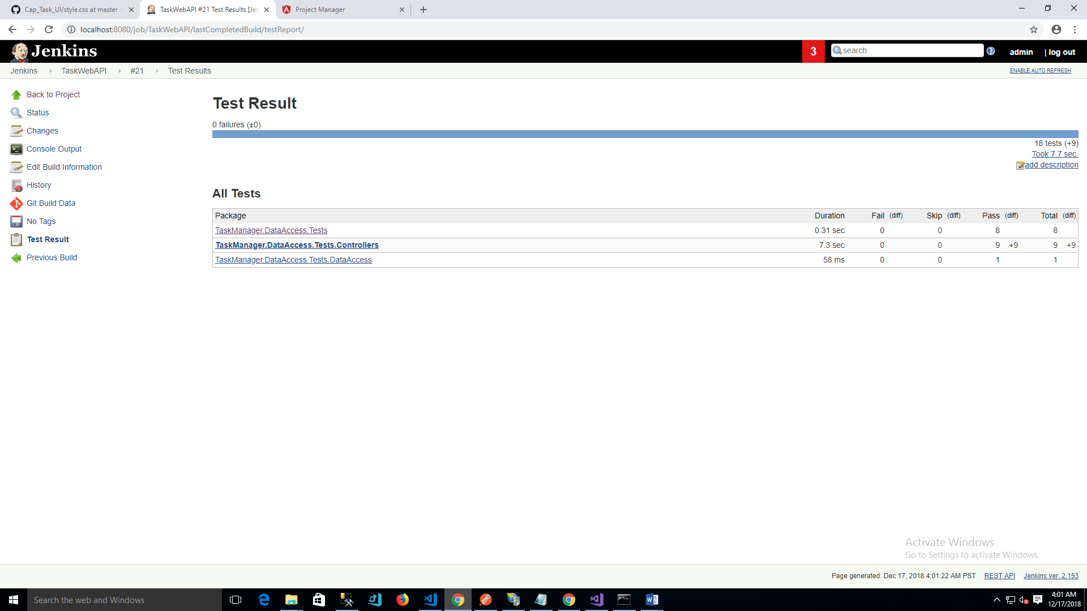

Output:

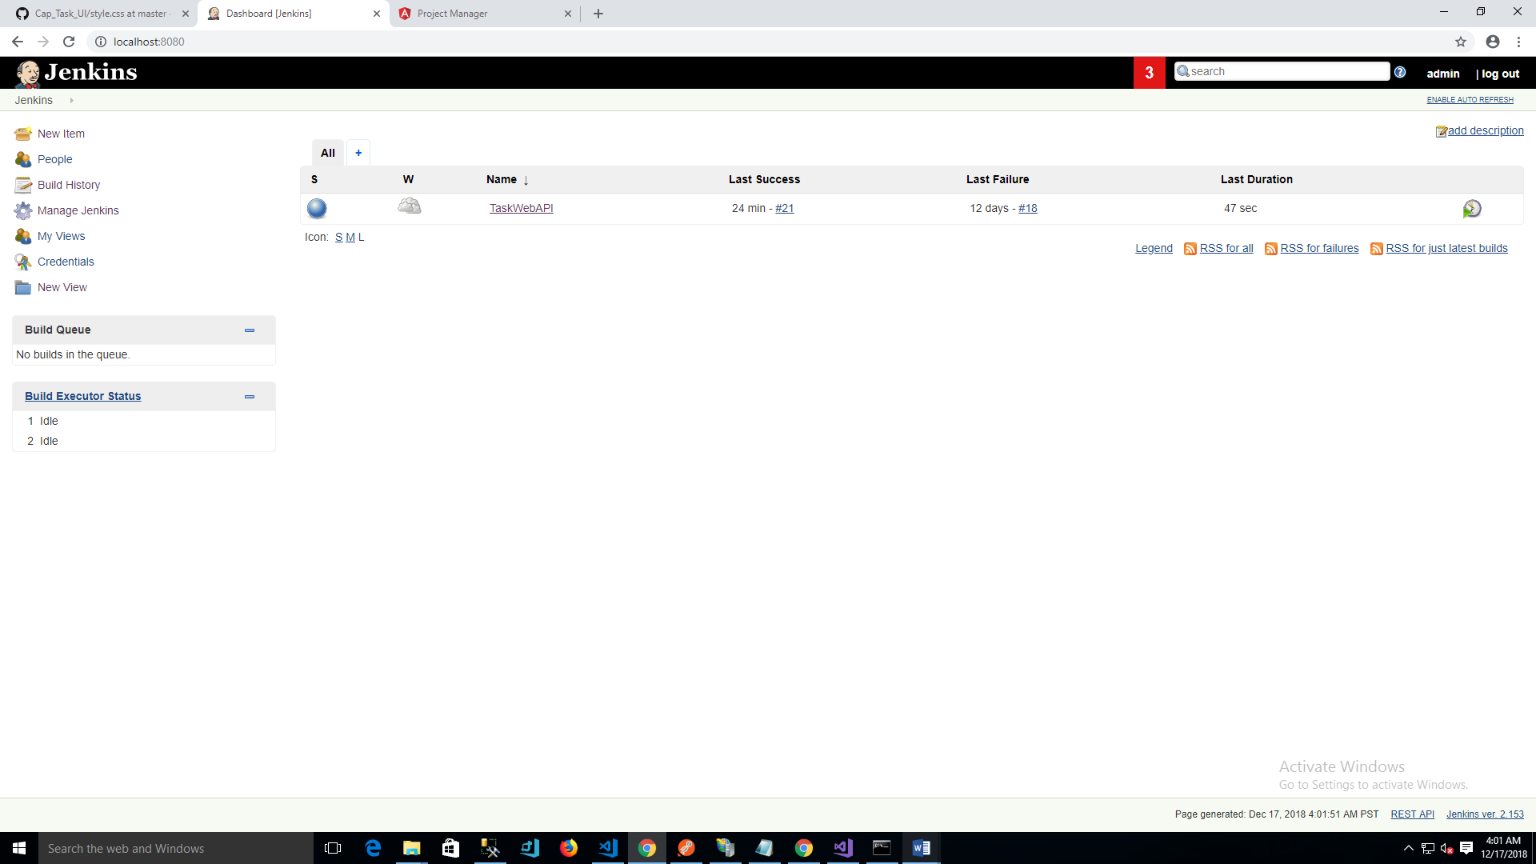

**IIS Task API hosting**

Task API hosting

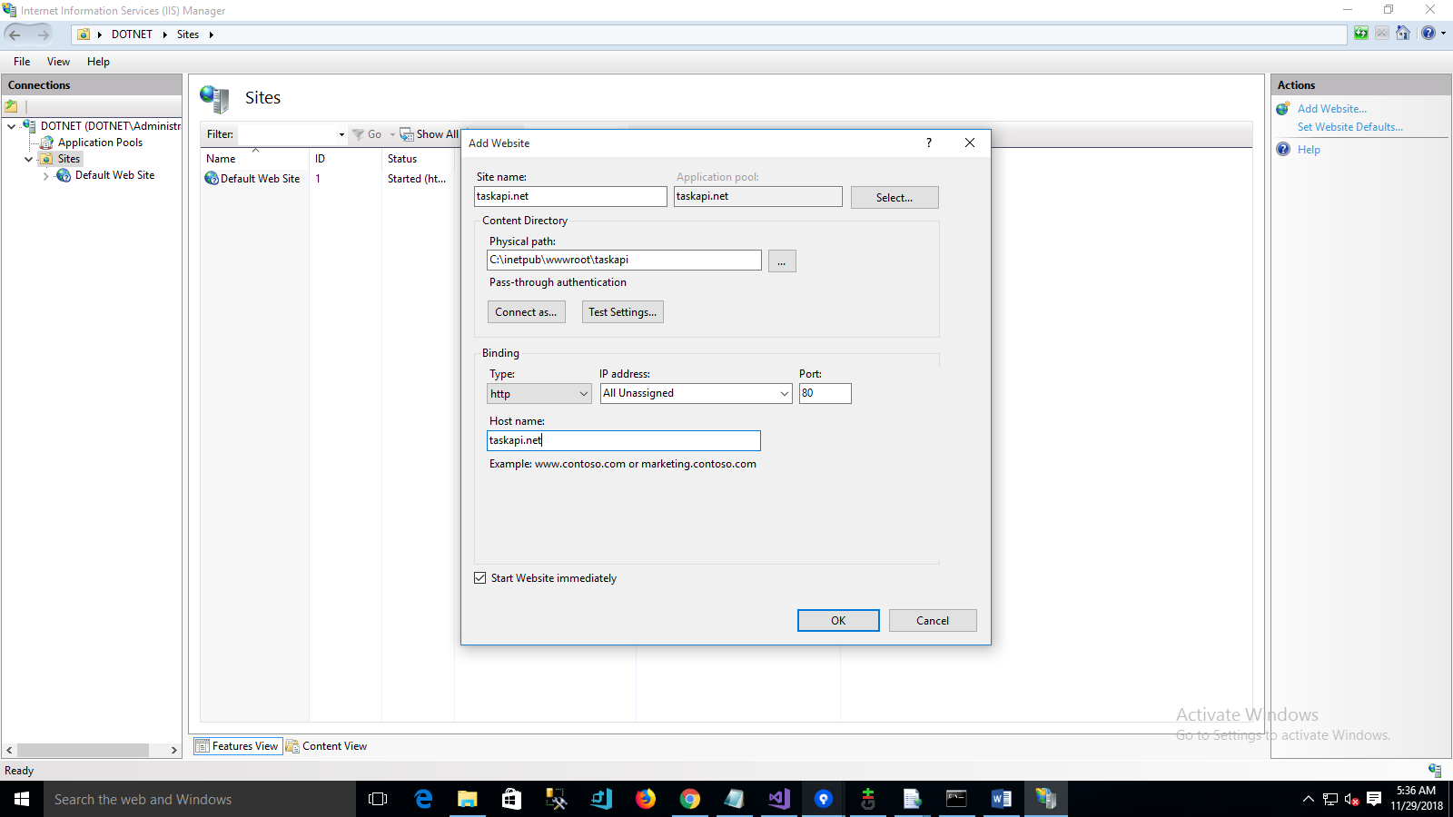

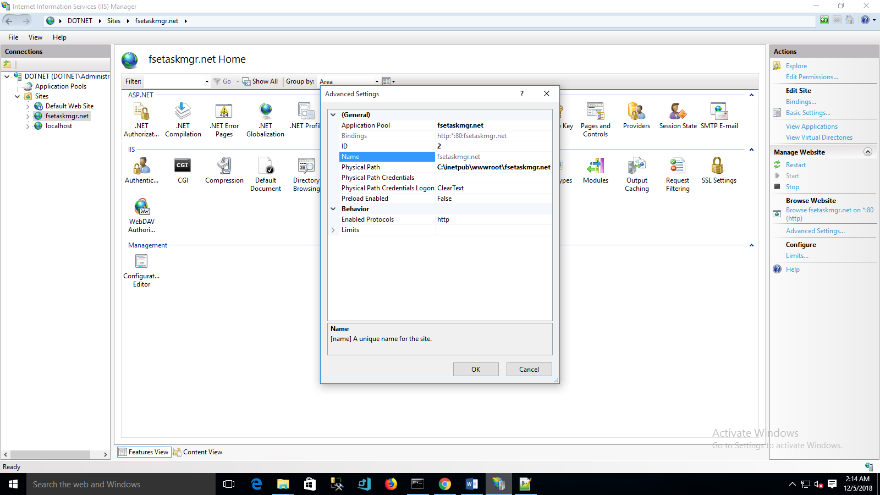

IIS Site applicaion pool setup:

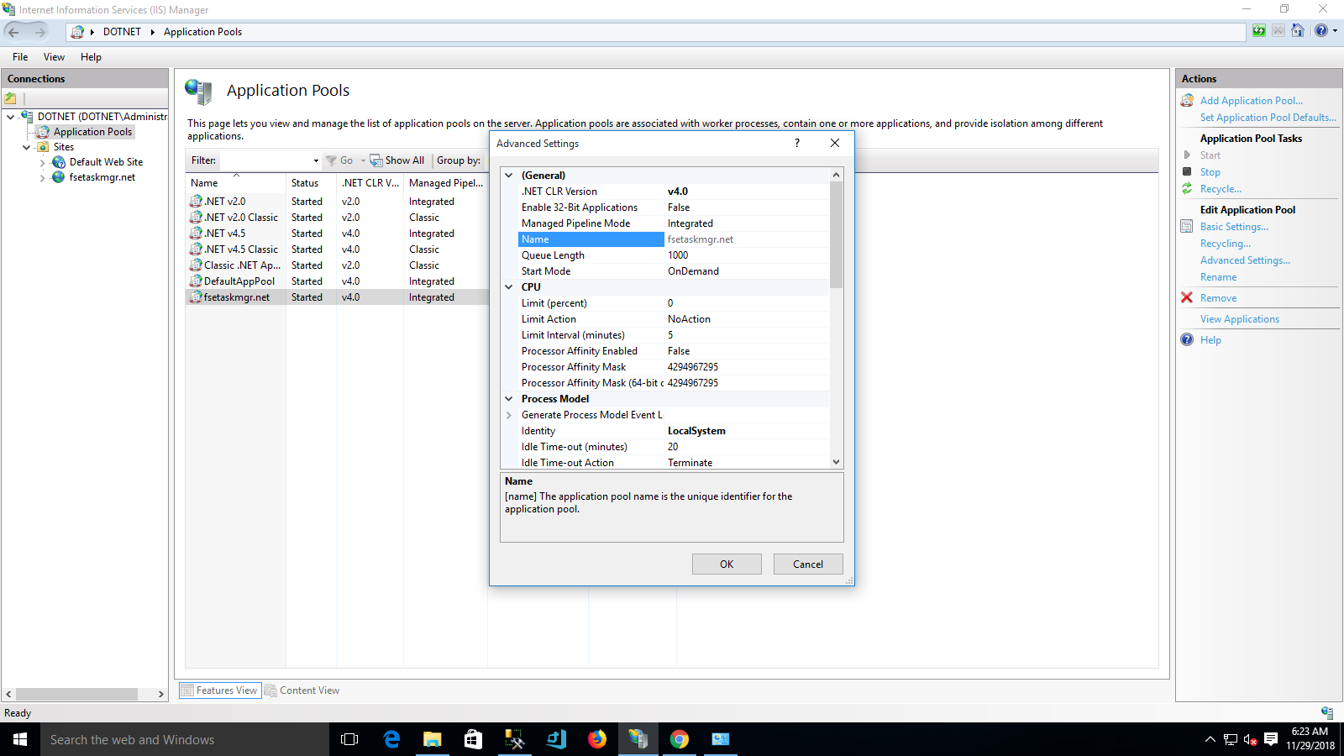

**IIS – Frontend deployment**

NG Build – Get deployment build

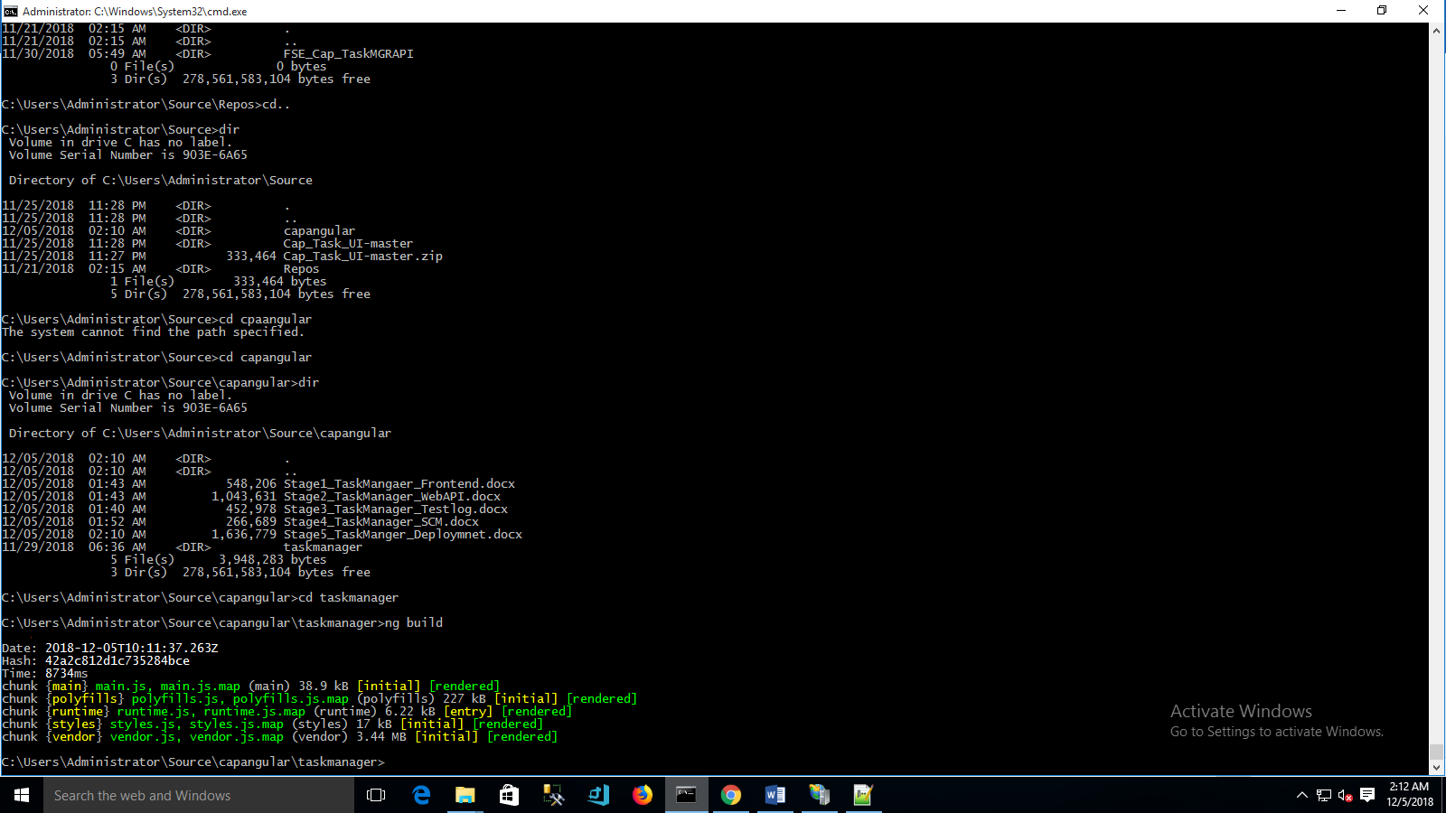

Build output

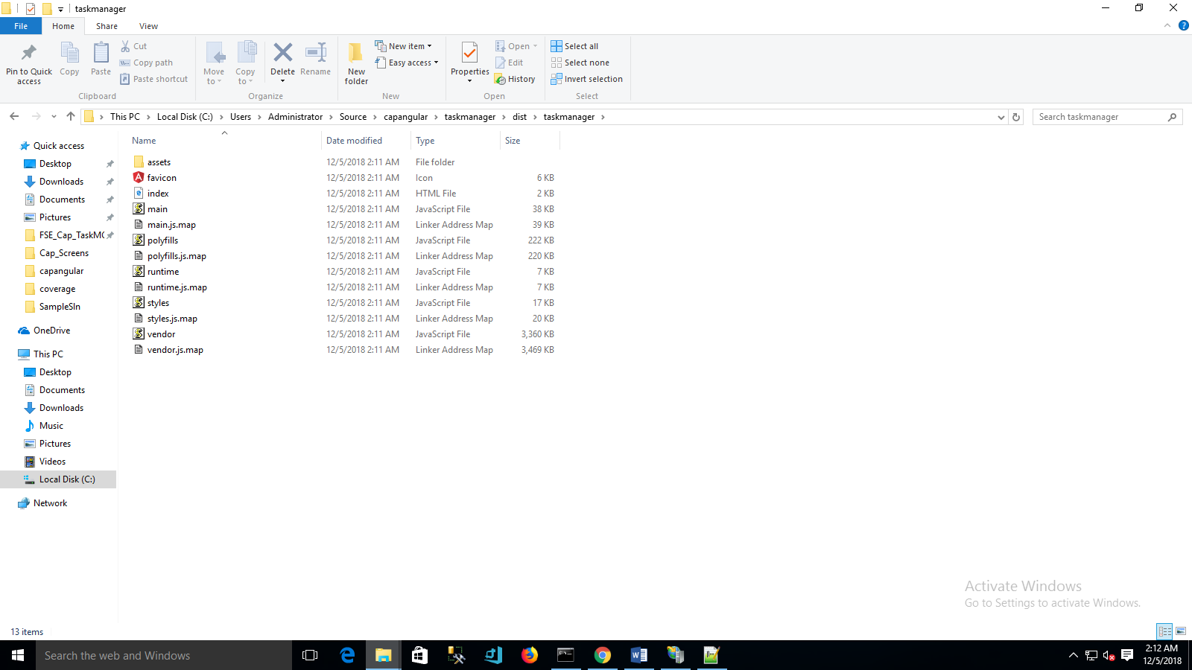

Task front end hosting

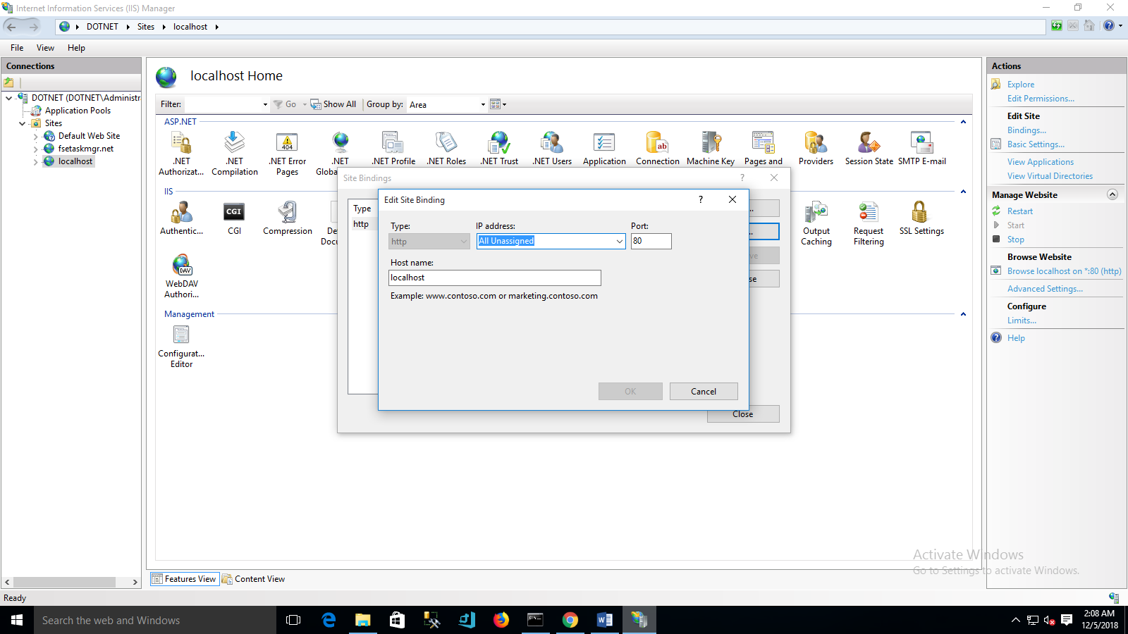

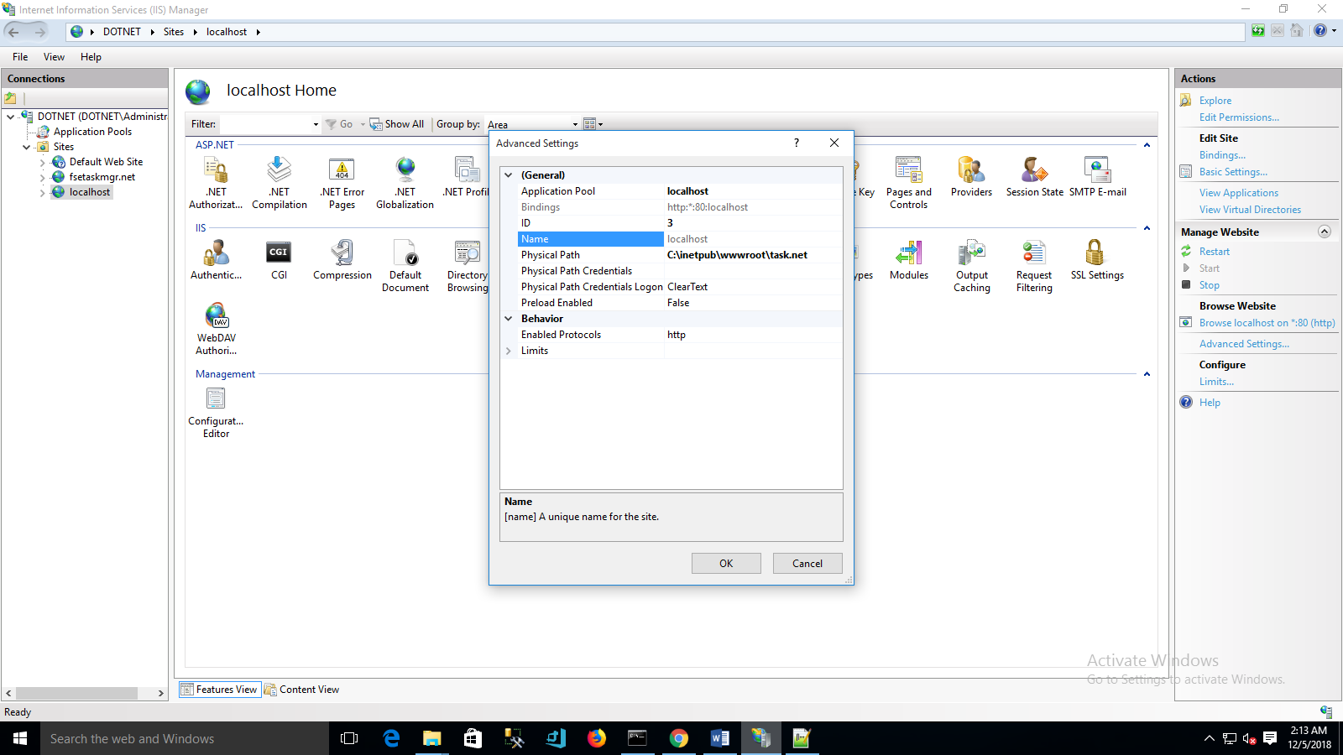

IIS Site applicaion pool setup:

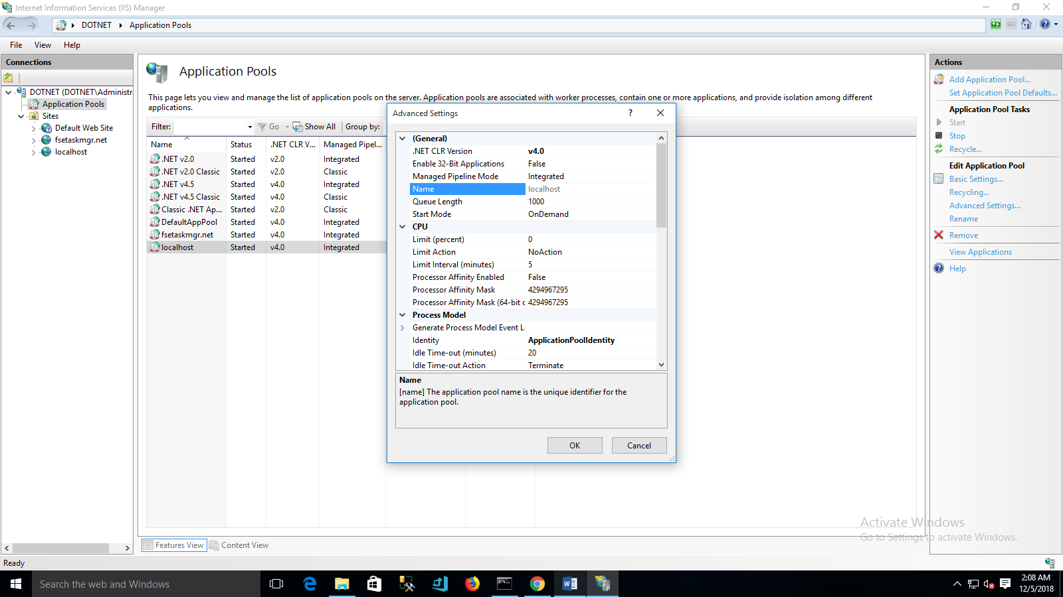

Host mapping

